Higher National Diploma in Information Technology
First Year, First Semester Examination – 2015
HNDIT1106/HNDIT11062 - Web Development
Marking Scheme

Instructions: No. of questions: 05
Answer four (04) questions. No. of pages : 05
All questions carry equal marks. Time : Two (02) hours

Question 1. [Total 25 Marks]
- Expand the following abbreviations
  - WWW – World Wide Web
  - TCP/IP – Transmission Control Protocol / Internet Protocol
  - FTP – File Transfer Protocol
  - HTTP – Hypertext Transfer Protocol [2 x 4 = 08 marks]

- Three types of internet connections are given as follows.
Dial-up, Broadband, Leased line
Using them, fill in the blanks of the sentences given below.
  - Leased line is the most expensive type of connection.
  - Dial Up is the least expensive and slowest connection.
  - Broadband is more appropriate for a student following an online course.
  - If a reputed finance company needs to connect their branch office for controlling daily transactions, Leased line is the most appropriate connection.
[1 x 4 = 04 marks]
- Identify following components of the given URL.

http://www.sliate.ac.lk/index.php
  - Organization Name - sliate
  - File name – index.php
  - Protocol - http
  - Service - WWW
  - Top level domain - lk [1 x 5 = 05 marks]

- a) Mention two (02) functions of an Internet Service Provider.
- Give users access to internet resources
- Allow organizations and individuals to publish information on the internet etc.
Give marks for any two factors [2 x 2 = 04 marks]

- List two factors customer need to consider before getting an internet connection? [1 x 4 = 04 marks]
          - Speed or bandwidth
          - Cost
          - Availability
          - Reliability
          - Convenience etc.
Give marks for any four factors.

Question 2. [Total 25 Marks]
- Briefly describe Collaborative web site and give two examples.
A collaborative Web site is a website which comprises the perpetual collective work of many authors. [02 marks]
E.g. Wikis, Blogs, social networking web sites etc.
(Give marks for any two examples) [02 marks]
- Briefly explain three (03) differences between static websites and dynamic websites.
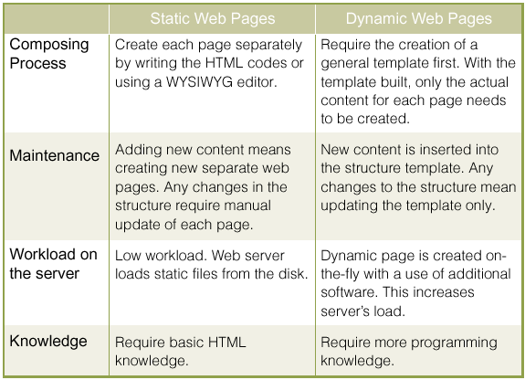
Give marks for any three differences. [3 x 2 = 06 marks]

- Give two (02) social networking web sites and list any two (02) features of each site?
Give marks for any two social networking websites such as facebook, twitter, myspace etc. [02 marks]
Features may include Timeline, Events, Social plug-ins etc.
Give marks for any two features for each. [2 x 2 = 04 marks]
E.g. Facebook features could include relationship status, news feed etc.
- E-commerce consists of buying and selling of products or services over electronic systems such as the Internet and other computer networks.
  - Give three (03) features of an ecommerce web site?
- Product information
- Addition of new products
- Shopping carts
- Credit card processing
- Sales report generation
- Rich User Accounts
- Product Comparison etc.
Give marks for any three features. [1 x 3 = 03 marks]

  - Briefly describe three benefits of PayPal - the most popular ecommerce payment system.
- PayPal enables buyers and businesses to send and receive money online.
- Make purchases or send money with PayPal
- It’s free Shop and pay conveniently by saving your information with PayPal
- PayPal is accepted by millions of businesses worldwide and is the preferred payment method on eBay etc.
Give marks for any three benefits. [3 x 2 = 06 marks]

Question 3. [Total 25 Marks]
- a) What do you mean by Computer security? [03 marks]
Techniques for ensuring that data stored in a computer cannot be read or compromised by any individuals without authorization.
b) State three (03) goals of computer security.
- Integrity
- Confidentiality
- Authentication
- Reliability
(Give marks for any three) [1 x 3 = 03 marks]
- Briefly explain two (02) malicious software that brings harm to a computer system.
Give marks for descriptions of Virus, Worms, Trojans etc.
[2 x 2 = 04 marks]
- What is the difference between hackers and crackers? [03 marks]
A hacker’s aim is to fix flaws within systems and to improve their security, without doing any damage to the system or causing any economic loss. Many times hackers are IT security professionals, who are hired by companies in order to audit network security or to test software for design flaws.
Instead, crackers break into systems illegally for personal gain or vandalism. Most crackers are not very knowledgeable or skillful with programming ability, so unlike hackers they rely on automated programs that are downloaded from disreputable websites.

- What are the technologies design to protect network connections and data transfer over the internet? Briefly explain three (03) technologies.
- User Authentication
- Virtual private networks (VPNs)
- Data Encryption
- Firewalls etc. [03 marks]
Give 03 marks for descriptions of three (03) technologies. [03 Marks]

- “Internet has become easier to spread viruses.” Do you agree or disagree? Justify your answer.
Give marks for any correct justification. [06 Marks]

Question 4. [Total 25 Marks]
- a) What does HTML stand for?
Hypertext Markup Language [02 marks]
b) Write the format of the basic HTML document.
<HTML>
<HEAD>
<TITLE> </TITLE>
</HEAD>
<BODY>
This is what is displayed.
</BODY>
</HTML> [03 marks]

- State two (02) attributes for each of the following HTML tags.
- <BODY> - bgcolor , background , text etc.
- <FONT> - size , color etc.
- <TABLE> - width , border etc.
- <FRAME> - src , name [4 x 2 = 08 Marks]

- Write HTML Code to generate the Web page given below.
Use the following criteria, when writing the HTML Code:
- Font of the Heading in web page is “Algerian”.
- Picture used in the page is “www.jpg”.
- “Go To W3SCHOOLS” text is linked with “www.w3schools.com” website.

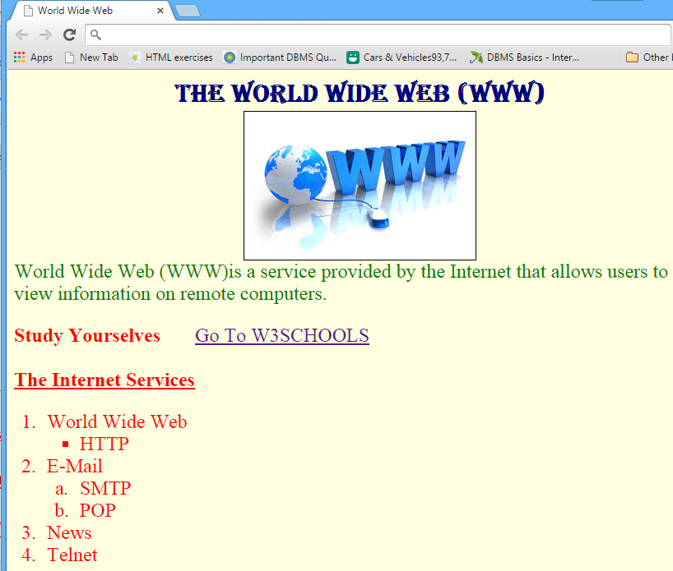
[12 marks]
<html>
<title>World Wide Web </title>
<head ><b><font face="Algerian" size="6" color="Navy" > <center>
The World Wide Web (WWW)</center></font></b></head>
<body bgcolor="lightyellow">
<center><img src="www.jpg" border="1"></center>
<font face="Times New Roman" size="5" color="green">
World Wide Web (WWW)is a service provided by the Internet that allows
users to view information on remote computers. </p>
<font face="Times New Roman" size="5" color="red">
<b>Study Yourselves</b> &nbsp &nbsp &nbsp
<a href="http://www.w3schools.com"> Go To W3SCHOOLS</a>
<br> <br> <b><u>The Internet Services </b></u>

<ol type="1">
<li> World Wide Web</li>
<ul type="square">
<li> HTTP</li>
</ul>
<li>E-Mail</li>
<ol type ="a">
<li> SMTP </li>
<li> POP </li>
</ol>
<li>News</li>
<li>Telnet</li> </ol> </body> </html>
Question 5. [Total 25 Marks]
- What does CSS stand for and what is the purpose of this technology?
Cascading Style Sheet [01 mark]
CSS allows you to style HTML elements, or define how they are displayed.
[02 marks]
- State two (02) properties of a form.
- Forms work in all browsers.
- Forms are Platform Independent.
- not only provide the person viewing the document with dynamic information but also to obtain information from the person viewing it, and process the information
[2 x 2 = 04 Marks]
- Draw the output of the following code segment.
<TABLE border="1" width="300">
<TR>
<TH colspan="4"> Students' Passed Rate </TH>
</TR>
<TR>
<TH rowspan="2"> Year </TH>
<TH colspan="2"> Gender </TH>
<TH rowspan="2"> Passed Rate % </TH>
</TR>
<TR>
<TH> Male </TH>
<TH>Female </TH>
</TR>
<TR align="center">
<TD> First Year </TD>
<TD> 83 </TD>
<TD> 50 </TD>
<TD> 85 </TD>
</TR>
<TR align="center">
<TD> Second Year </TD>
<TD> 41 </TD>
<TD> 45 </TD>
<TD> 73 </TD>
</TR>
</TABLE>
[06 marks]

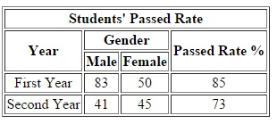

- Write HTML markup to produce the following output.

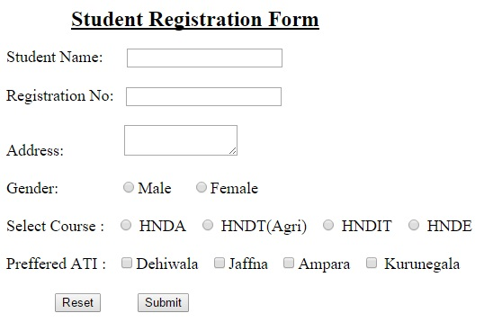 [12 Marks]
<form>
<br>
<font size="4"> Student Name: &nbsp &nbsp &nbsp<input type="text" ><br><br>
Registration No: &nbsp <input type="text" ><br><br>
Address: &nbsp &nbsp &nbsp &nbsp &nbsp &nbsp &nbsp
<textarea rows="2" cols="15"> </textarea>
<br><br>

Gender: &nbsp &nbsp &nbsp &nbsp &nbsp &nbsp &nbsp
<input type="radio" name="gender">Male &nbsp &nbsp
<input type="radio" name="gender">Female<br> <br>

Select Course : &nbsp
<input type="radio" name="course" > HNDA &nbsp
<input type="radio" name="course" > HNDT(Agri) &nbsp
<input type="radio" name="course" > HNDIT &nbsp
<input type="radio" name="course" > HNDE<br><br>

Preffered ATI : &nbsp
<input type="checkbox" >Dehiwala &nbsp
<input type="checkbox" >Jaffna &nbsp
<input type="checkbox" >Ampara &nbsp
<input type="checkbox" > Kurunegala <br><br>
&nbsp &nbsp &nbsp &nbsp &nbsp &nbsp
<input type="Reset" value="Reset"> &nbsp &nbsp &nbsp &nbsp
<input type="submit" value="Submit">

